Validating the Availability zone of the EC2 instance with which you want to add volume

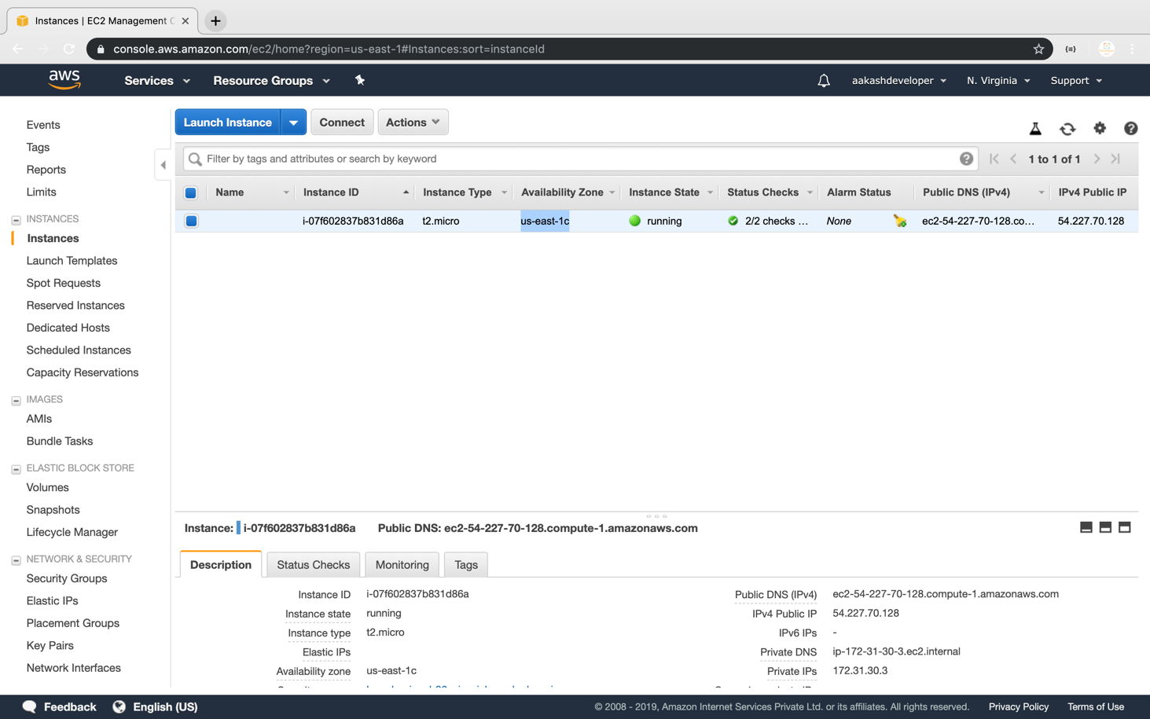

Providing type, size, availability zone, and snapshot name on the **create volume** tab

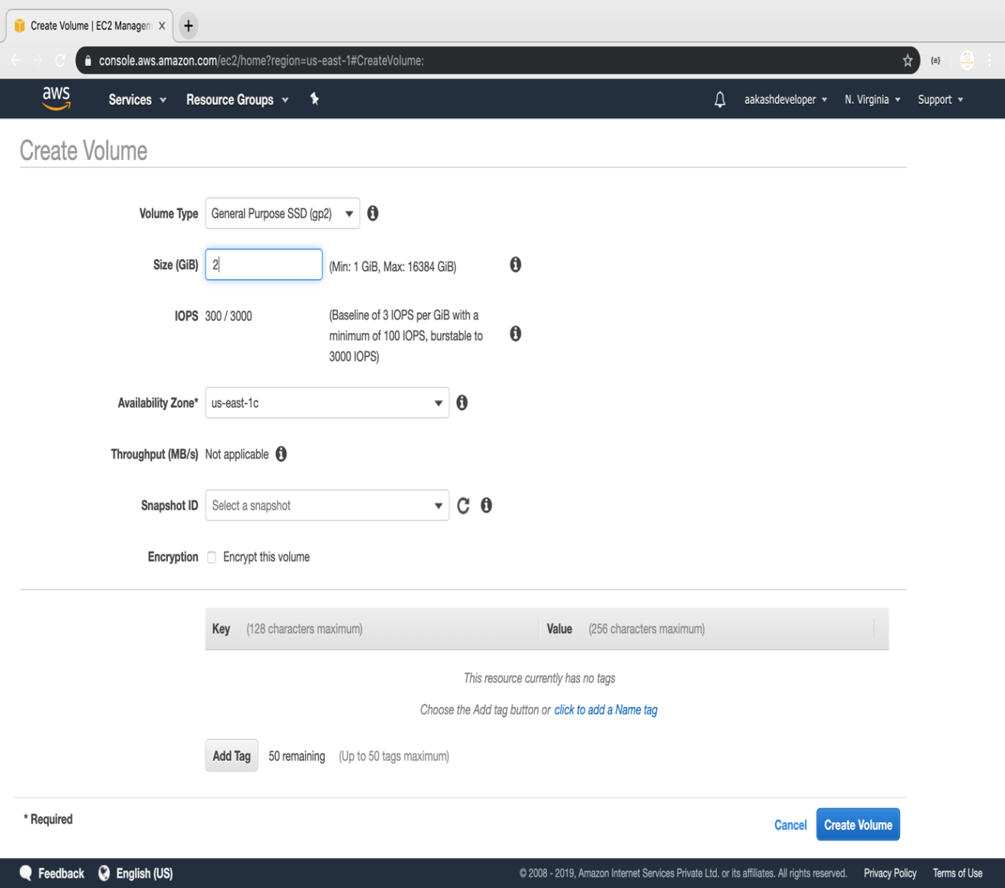

Selecting newly created volume and clicking on the action to attach the volume to the instance

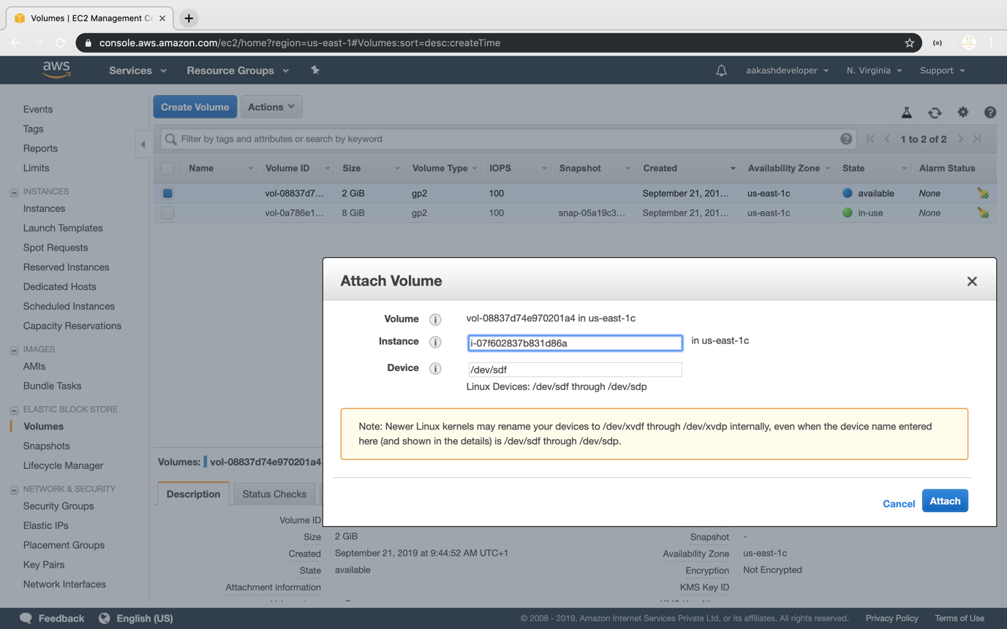

Verifying the instance by adding one more device to the block device

